**Information and support for Adults and Young People**

Following on from the sad loss of a young life in the Cootehill community, it is important to remember that our community supports and services are still operating. It is also important that we look out for each other and reassure our young people that they are not alone in their grief and that help is available. Most people will access support through their friends, their family, their Teachers, Sports Coaches and anyone else they are closely connected with.

If additional help is needed, your GP is your first point of contact in relation to both physical and mental health needs. If you, or someone you know is in crisis, contact your GP or contact North East Doc on Call on 1800 777 911 during out of hours (evening and weekends), or if you are really concerned, go to the Emergency Department in Cavan General Hospital.

**LOCAL SUPPORT AND SERVICES – COOTEHILL**

|  |  |
| --- | --- |
| **Service** | **Contact Details** |
| **HSE Primary Care Psychology, Cavan** | **Phone 049 435 3100 for information - referrals are accepted from your GP/ Health Care Professional** |
| **HSE Child & Adolescent Mental Health Services** | **This service is accessed via GP referral** |
| **HSE Adult Mental Health Services** | **This service is accessed via GP referral** |
| **Pieta House Suicide Bereavement Liaison Officer** | **Contact Maria on 085 870 6591 or email maria.mcbrien@pieta.ie** |
| **Pieta House Crisis Counselling Service** | **Phone 0818 111 126 to make an appointment** |
| **ISPCC** | **BounceBack Youth Service - One to One support. Contact Karen on 087 353 3070, or email Karen.Heaslip@ispcc.ie** |
| **Youth Work Ireland** | [**www.facebook.com/BounceBackYouthService**](http://www.facebook.com/BounceBackYouthService)**/  Instagram:**[**www.instagram.com/ywi_cm/**](http://www.instagram.com/ywi_cm/) |
| **Foroige** | **Contact Sharon on 086 779 1685 or email sharon.ivers@foroige.ie** |
| **Cavan Monaghan Rainbow Youth** | **Contact Padraig on 087 219 3904, @CAMrainbowyouth** |

|  |  |
| --- | --- |
| **Teach Oscail Family Resource Centre**, **Cavan** | **Contact 049 437 2730 or email** [**info@teachoscailfrc.ie**](mailto:info@teachoscailfrc.ie) |
| **SOSAD Cavan** | **Call 049 432 6339 24 hours a day, 7 days per week or email** [**sosadcavan@gmail.com**](mailto:sosadcavan@gmail.com) |
| **Tusla Prevention Partnership & Family Support, Cavan** | **Contact Antoinette on 049 436 9800** |
| **MQI - CAMDAS (Cavan & Monaghan Drug & Alcohol Service)** | **Contact Zoe on 049 437 9160 or email** [**info.cavan.monaghan@mqi.ie**](mailto:info.cavan.monaghan@mqi.ie) |
| **An Garda Siochana, Cavan office** | **Contact 042 969 4570 or in an emergency**  **phone 999 or 112** |

**NATIONAL SUPPORT AND SERVICES**

|  |  |
| --- | --- |
| **Service** | **Contact Details** |
| **Samaritans** - 24/7 helpline for all ages | **Tel: 116 123** |
| **Pieta House** - 24/7 helpline for all ages | **Tel: 1800 247 247** |
| **Crisis Text Line** - 24/7 text service for young people aged 12 - 34 | **Text TALK to 50808** |
| **ISPCC Childline** - 24/7 helpline for young people up to 18 years | **Tel: 1800 66 66 66 or free text to 50101** |
| **ISPCC Teenline** free 24/7 helpline for young people up to 18 years | **Tel: 1800 833 634** |
| **Women’s Aid National Freephone Helpline** | **Tel: 1800 341 900** |
| **Money Advice & Budgeting Service (MABS)** | **Tel: 0818 072 000**  [**www.mabs.ie**](http://www.mabs.ie) |
| **HSE Drugs & Alcohol Helpline** | **Freephone: 1800 459 459** |
| **National Bereavement Support Line**  **(Mon – Fri, 10 am – 1 pm)** | **Freephone: 1800 807 077** |
| **Online Counselling & Support** | [**www.mymind.org**](http://www.mymind.org) **or** [**www.turn2me.ie**](http://www.turn2me.ie) |

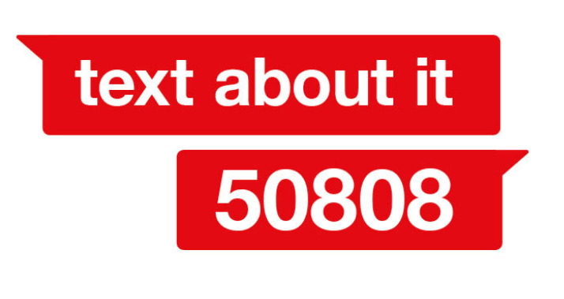

50808 is a first of its kind for Ireland: a free 24/7 text service, providing everything from a calming chat to immediate support for people going through a mental health or emotional crisis - big or small.

From breakups or bullying, to anxiety, depression and suicidal feelings, our Crisis Volunteers are available 24/7 for anonymous text conversations.

Visit **yourmentalhealth.ie** for information and signposting on all mental health supports and services that are available nationally & locally provided by the HSE & funded partners.

You can also call the Freephone Your Mental Health Information Line to find supports and services **1800 111 888** (any time, day or night).

Download the Youthwork Ireland Cavan Monaghan Connecting You app for - information and support for young people - [https://www.ywimonaghan.ie/connecting-you-youth-work-irelands-new-information-app/](https://scanner.topsec.com/?d=2120&t=1fba7a27dc0302de0ca807aed43754240d4947e5&r=show&u=https%3A%2F%2Fwww.ywimonaghan.ie%2Fconnecting-you-youth-work-irelands-new-information-app%2F)