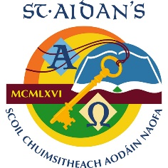
ST AIDAN’S COMPREHENSIVE SCHOOL
ANNUAL ADMISSION NOTICE
In respect of admissions to the 2024/2025 school year
Admissions Policy and Application Form
A copy of the school’s Admission Policy and the Application Form for Admission for the school year 2023-2024 is available as follows: -
To download at: www.staidans.ie on request: 049 5552161 by emailing office@staidans.ie
or writing to St Aidan’s Comprehensive School Cootehill, Co Cavan H16CV91

PART 1 –Admissions to the 2024/2025 School Year
APPLICATION AND DECISION DATES for admissions to 2024/2025
The following are the dates applicable for admission to First Year
The school will commence accepting applications for admission on | 02.10.2023
The school will cease accepting application for admissions on | 13.11.2023
The date by which applicants will be notified of the decision on their application is | 24.11.2023
The period within which applicants must confirm acceptance of an offer of admission is | 08.12.2023

Note: the school will consider and issue decisions on late applications in accordance with the school’s admission policy.
HEARING IMPAIRED CLASS APPLICATION and Decision Dates for admission to 2024/2025
The following are the dates applicable for admission to the school’s Hearing Impaired Class which caters for children with a Hearing Impairment.
The school will commence accepting applications for admission to the Hearing Impairment Class | 02.10.2023
The school will cease accepting application for admission to the Hearing Impairment Class | 13.11.2023
The date by which applicants will be notified of the decision on their application for admission to the Hearing Impairment Class | 24.11.2023
The period within which applicants must confirm acceptance of an offer of admission is | 08.12.2023
*Failure to accept an offer within the prescribed period above may result in the offer being withdrawn
NUMBER OF PLACES being made available in 2024/2025
The number of places being made available in first year is | 120
The number of places being made available in the Hearing Impaired class* catering for children with a Hearing Impairment is | 3

